# GUEST

## Sign in

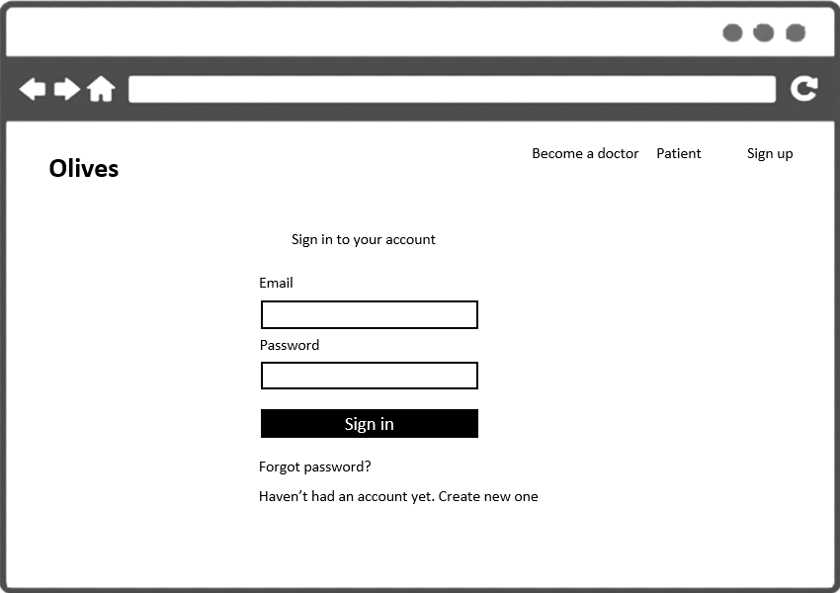

|  |  |  |
| --- | --- | --- |
| Element | Type | Description |
| Sign In | Button | Click to sign in |
| Email | Input Text | Text filed for entering name of user |
| Password | Input Text | Text field for entering password of user |
| Forgot password? | Hyperlink | Go to page to change to new password |
| Create new one | Hyperlink | Go to sign up page |

## Sign up

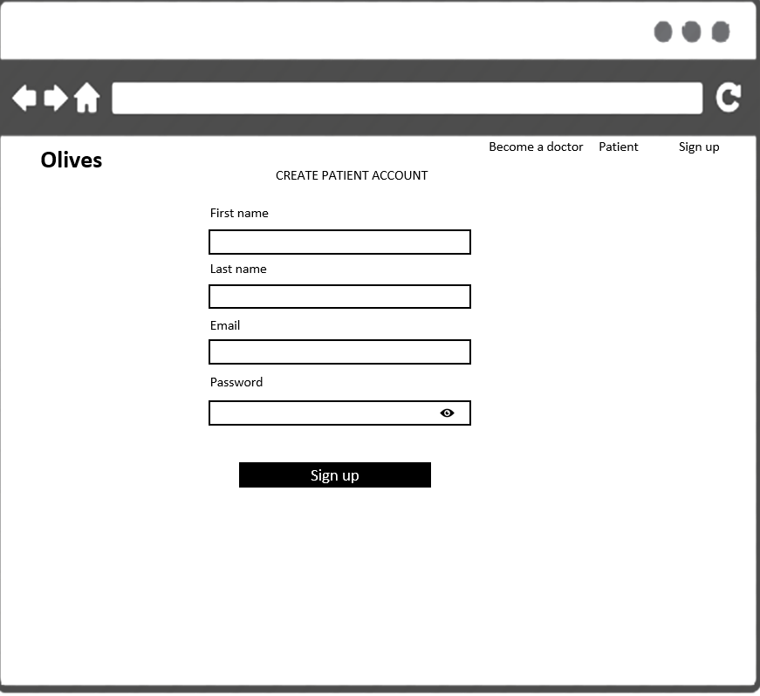

|  |  |  |
| --- | --- | --- |
| Element | Type | Description |
| Sign up | Button | Click to sign up |
| First name | Input Text | Text filed for entering first name of user |
| Last name | Input Text | Text field for entering last name of user |
| Email | Input Text | Text field for entering email of user |
| Password | Input Text | Text field for entering password of user |

Doctors

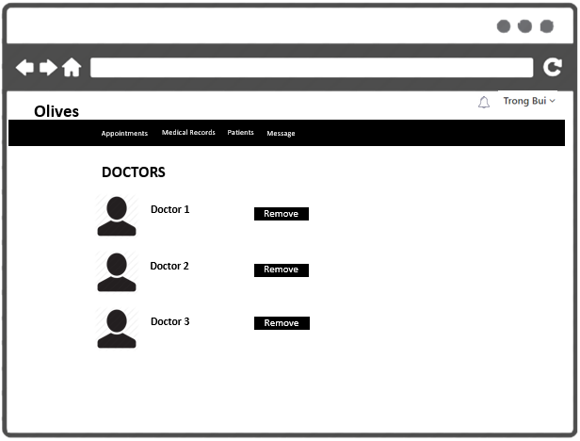

|  |  |  |
| --- | --- | --- |
| Element | Type | Description |
| Remove | Button | Click to remove doctor |
| Doctor 1 | Input Text | Text filed for display name of doctor |

## Sign up

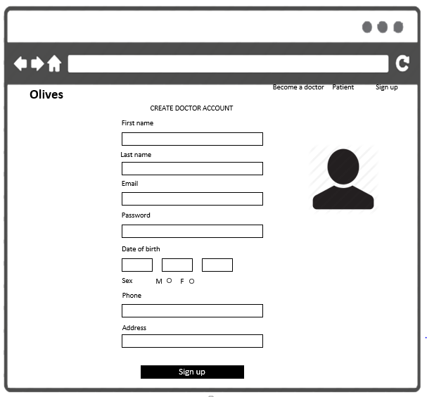

|  |  |  |
| --- | --- | --- |
| Element | Type | Description |
| First name | Input Text | Text filed for entering first name |
| Last name | Input Text | Text filed for entering last name |
| Email | Input Text | Text field for entering email |
| Password | Input Text | Text filed for entering password |
| Date of birth | Input Text | Text filed for entering date of birth |
| Sex | Radio button | Text filed for entering sex |
| Phone | Phone | Text filed for entering phone |
| Address | Input Text | Text filed for entering address |
| Sign up | Button | Click to sign up |

# DOCTOR

## User options

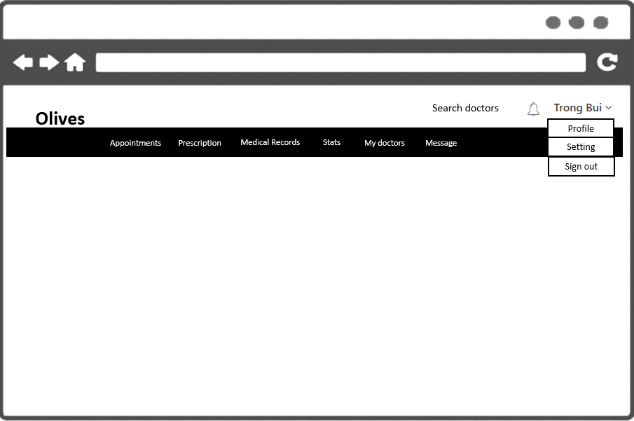

|  |  |  |
| --- | --- | --- |
| Element | Type | Description |
| Profile | Hyperlink | Go to user’s profile |
| Settings | Hyperlink | Go to user settings |
| Sign out | Hyperlink | Go to sign user out |

## View profile

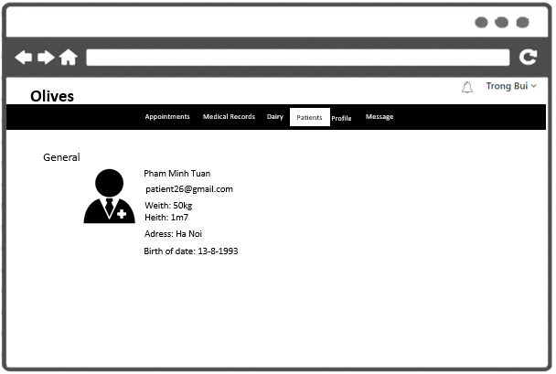

|  |  |  |
| --- | --- | --- |
| Element | Type | Description |
| Name | Text field | Text filed for entering name of user |
| Email | Hyperlink | Link to email |
| Specialty | Text field | Text field for displaying specialty |
| Sex | Text field | Text field for displaying sex |
| Address | Text field | Text field for displaying address |
| Place | Text field | Text field for display place |
| Photo | Image | Image for displaying photo |

## Settings - password

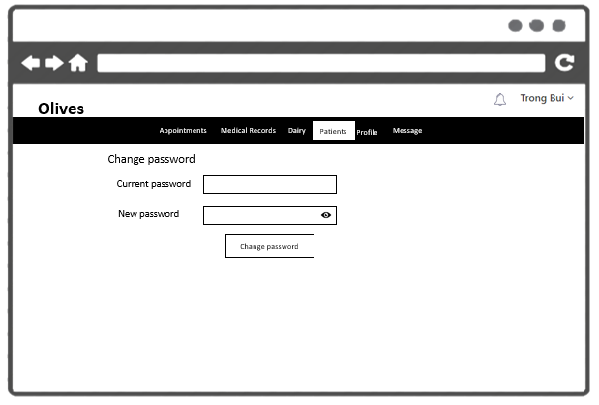

|  |  |  |
| --- | --- | --- |
| Element | Type | Description |
| Old password | Text field | Text input for entering old password |
| New password | Text field | Text input for entering new password |
| Change password | Button | Click to submit change |

## Settings-photo

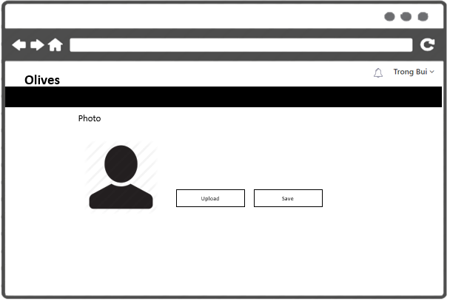

|  |  |  |
| --- | --- | --- |
| Element | Type | Description |
| Upload | Button | Click to upload photo |
| Save | Button | Click to submit change |

## Settings-profile

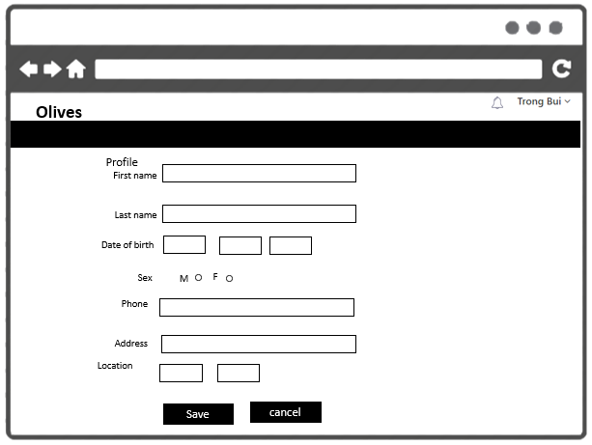

|  |  |  |
| --- | --- | --- |
| Element | Type | Description |
| First name | Text input | Text filed for entering first name |
| Last name | Text input | Text filed for entering last name |
| Date of birth | Text input | Text field for entering date of birth |
| Sex | Text input | Text filed for entering sex |
| Phone | Text input | Text filed for entering phone |
| Address | Text input | Text filed for entering address |
| Location | Text input | Text filed for entering location |
| Save | Button | Click to save profile |
| Cancel | Button | Click to cancel editing |

## Notification

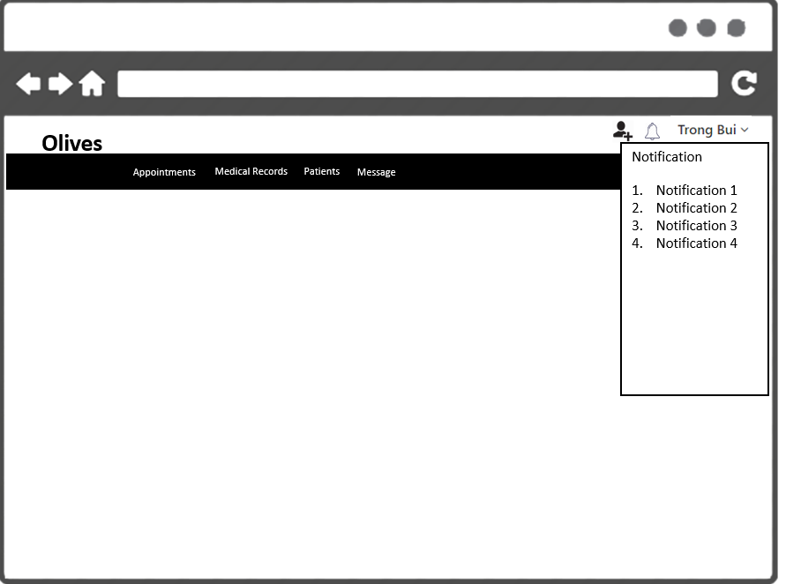

|  |  |  |
| --- | --- | --- |
| Element | Type | Description |
| Bell icon | Button | Click to show notification |
| List item | List element | Show all notification |

## Message

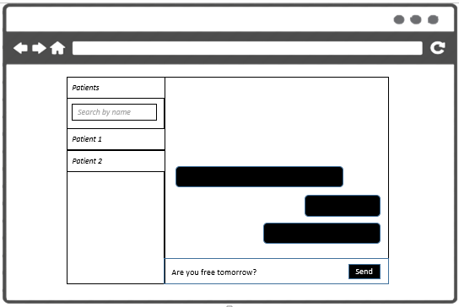

|  |  |  |
| --- | --- | --- |
| Element | Type | Description |
| Patient list | List of text fields | Displaying list of patients |
| Search | Text input | Text input for entering name of patient |
| Message list | List of text fields | Displaying list of messages |
| Content | Textarea | Textarea for entering message content |
| Send | Button | Click to send message |

## View request relationship

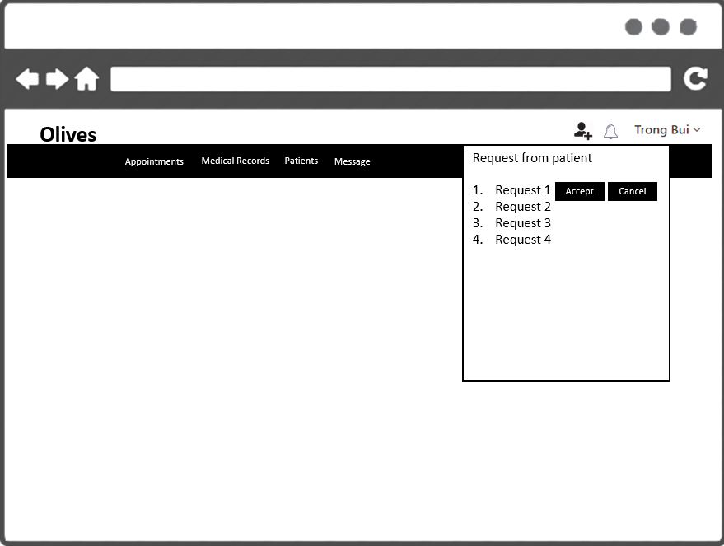

|  |  |  |
| --- | --- | --- |
| Element | Type | Description |
| Request list | List of text | Displaying list of requests |
| Accept | Button | Accept request |
| Cancel | Button | Cancel request |

## Patients

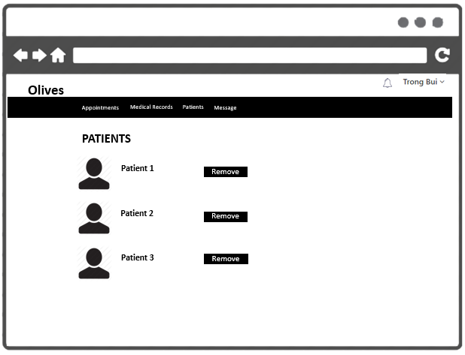

|  |  |  |
| --- | --- | --- |
| Element | Type | Description |
| Remove | Button | Click to remove patient |
| Patient1 | Input Text | Text filed for display name of patient |

## Patient profile



|  |  |  |
| --- | --- | --- |
| Element | Type | Description |
| Name | Text field | Text field for displaying name |
| Email | Hyperlink | Link to patient email |
| Photo | Image | Image displaying patient photo |
| Weight | Text field | Text field for displaying weight |
| Height | Text field | Text field for displaying height |
| Address | Text field | Text field for displaying address |
| Date of birth | Text field | Text field for displaying date of birth |

## View patient diary

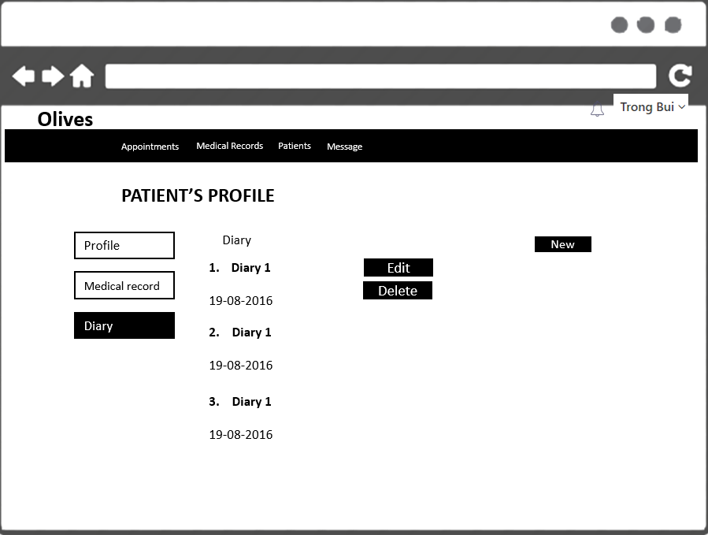

|  |  |  |
| --- | --- | --- |
| Element | Type | Description |
| Diary 1 | Text | Click to remove patient |
| Date | Text | Text filed for display name of patient |
| Edit | Button | Click to open edit page |
| Delete | Button | Click to delete item |
| New | Button | Click to open add new diary |

## Add diary

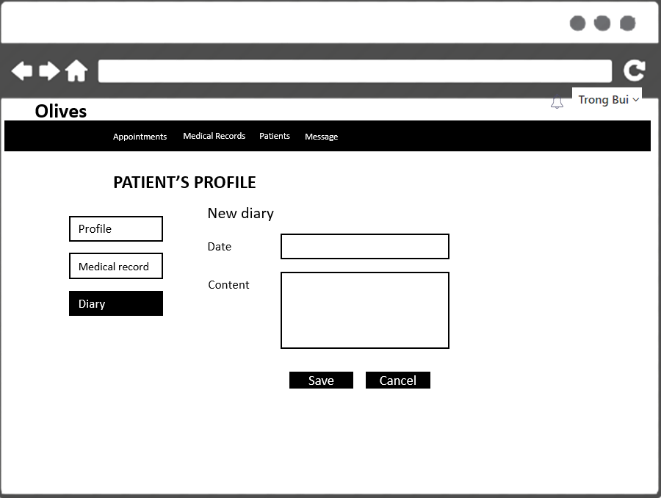

|  |  |  |
| --- | --- | --- |
| Element | Type | Description |
| Date | Input text | Text field for entering date |
| Content | Textarea | Text filed for entering content |
| Save | Button | Click to save item |
| Cancel | Button | Click to cancel action |

## Edit diary

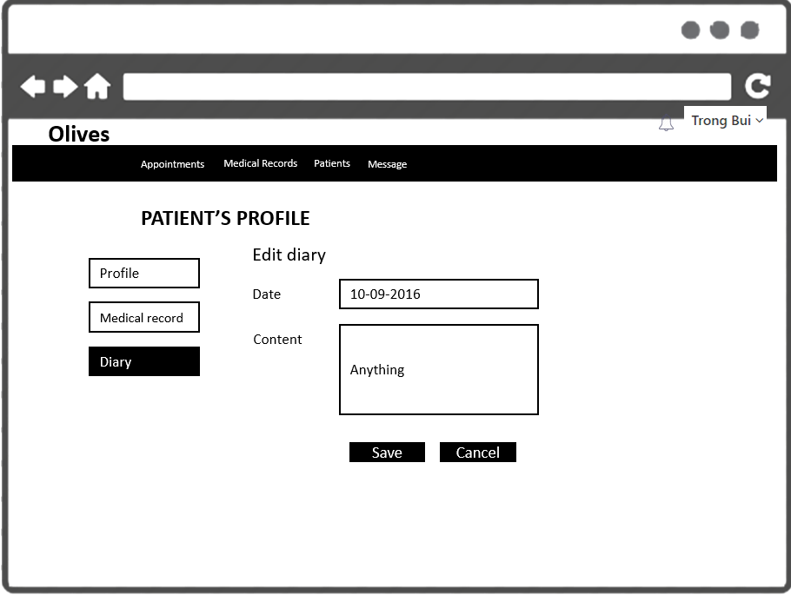

|  |  |  |
| --- | --- | --- |
| Element | Type | Description |
| Date | Input text | Text field for entering date |
| Content | Textarea | Text filed for entering content |
| Save | Button | Click to save item |
| Cancel | Button | Click to cancel action |

## Add appointment

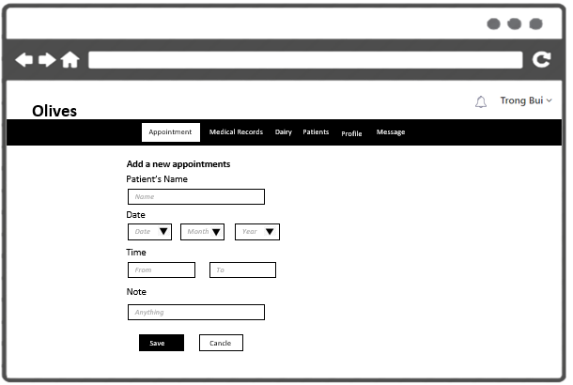

|  |  |  |
| --- | --- | --- |
| Element | Type | Description |
| Patient’s name | Input text | Text field for entering name |
| Date | Text input | Text filed for entering date |
| Time | Text input | Text field for entering time |
| Note | Textarea | Textarea for entering note |
| Save | Button | Click to save appointment |
| Cancel | Button | Click to cancel action |

## Edit appointment

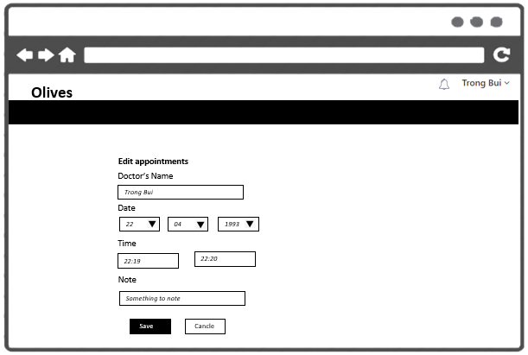

|  |  |  |
| --- | --- | --- |
| Element | Type | Description |
| Patient’s name | Input text | Text field for entering name |
| Date | Text input | Text filed for entering date |
| Time | Text input | Text field for entering time |
| Note | Textarea | Textarea for entering note |
| Save | Button | Click to save appointment |
| Cancel | Button | Click to cancel action |

## Accept appointment

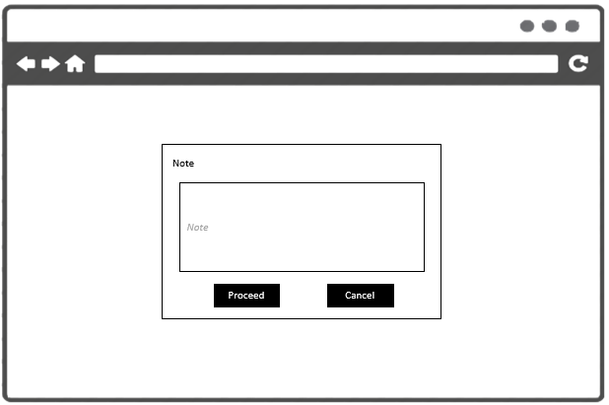

|  |  |  |
| --- | --- | --- |
| Element | Type | Description |
| Note | Input text | Text field for entering note |
| Proceed | Button | Click to accept appointment |
| Cancel | Button | Click to cancel action |

## Cancel appointment



|  |  |  |
| --- | --- | --- |
| Element | Type | Description |
| Note | Input text | Text field for entering note |
| Proceed | Button | Click to cancel appointment |
| Cancel | Button | Click to cancel action |

## View activated appointments

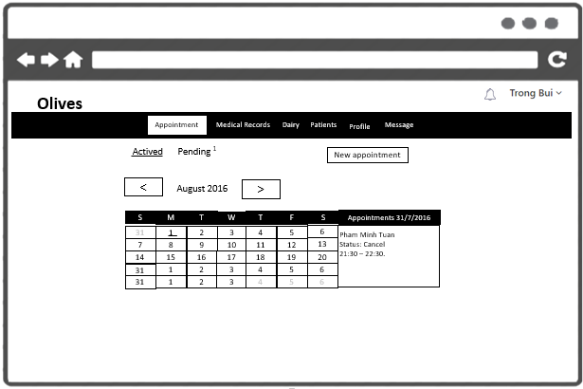

|  |  |  |
| --- | --- | --- |
| Element | Type | Description |
| Left arrow | Button | Click to show notification |
| Right arrow | Button | Show all notification |
| August 2016 | Button | Show month and year |
| Calendar | Calendar | Show days of month |
| Appointments | List element | Show all activated appointment |
| New appointment | Button | Click to go to add new appointment |

## View pending appointments

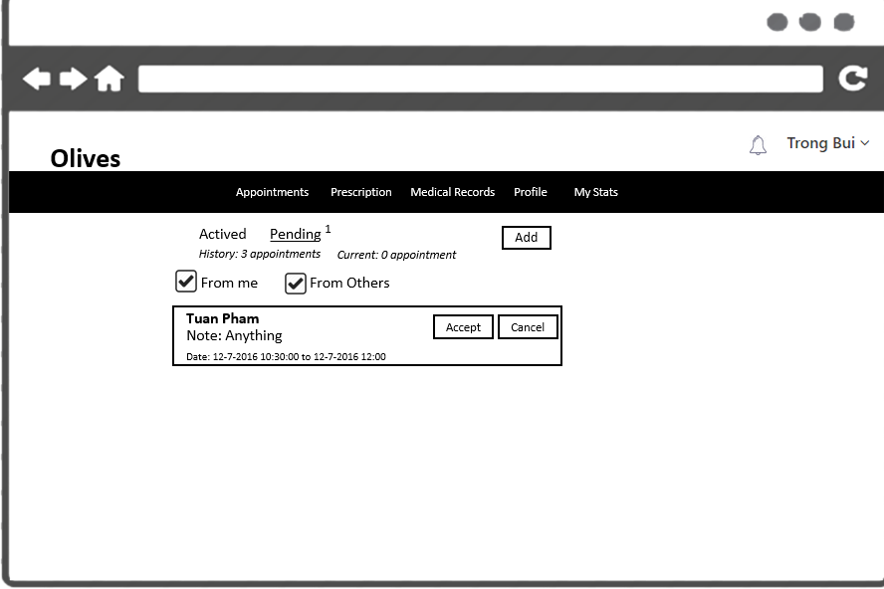

|  |  |  |
| --- | --- | --- |
| Element | Type | Description |
| From me | Checkbox | Radio button for get appointment created by doctor |
| From others | Checkbox | Radio button for get appointment created by patients |
| Name of partner | Button | Text field for displaying name |
| Note | Calendar | Text field for displaying note |
| Duration | List element | Text field for displaying appointment’s duration |
| Accept | Button | Click to accept appointment |
| Cancel | Button | Click to cancel appointment |

## Search appointment

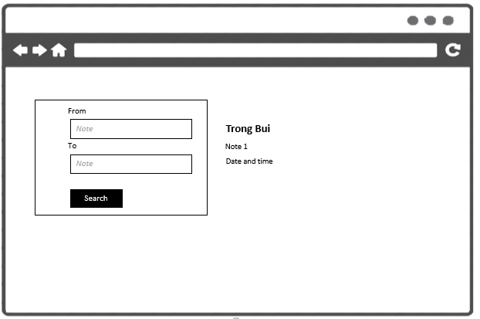

|  |  |  |
| --- | --- | --- |
| Element | Type | Description |
| From | Text input | Text input for entering duration |
| To | Text input | Text input for entering duration |
| Search | Button | Click to search |
| Partner’s name | Text | Text field for displaying partner’s name |
| Note | Text | Text field for displaying note |
| Time | Text | Text field for display time of appointment |

## View medical records

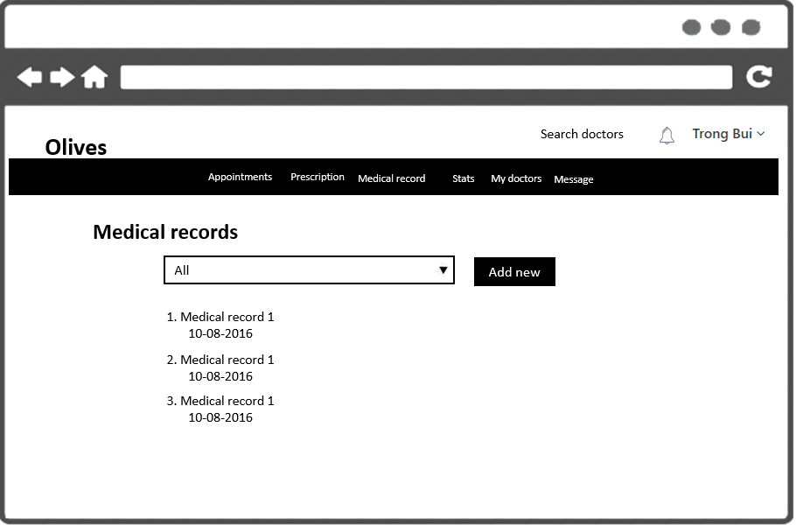

|  |  |  |
| --- | --- | --- |
| Element | Type | Description |
| Category selection | Selection | Select medical category |
| Add new | Button | Click to add new medical record |
| List item | List element | List of medical record |

## Add new medical record

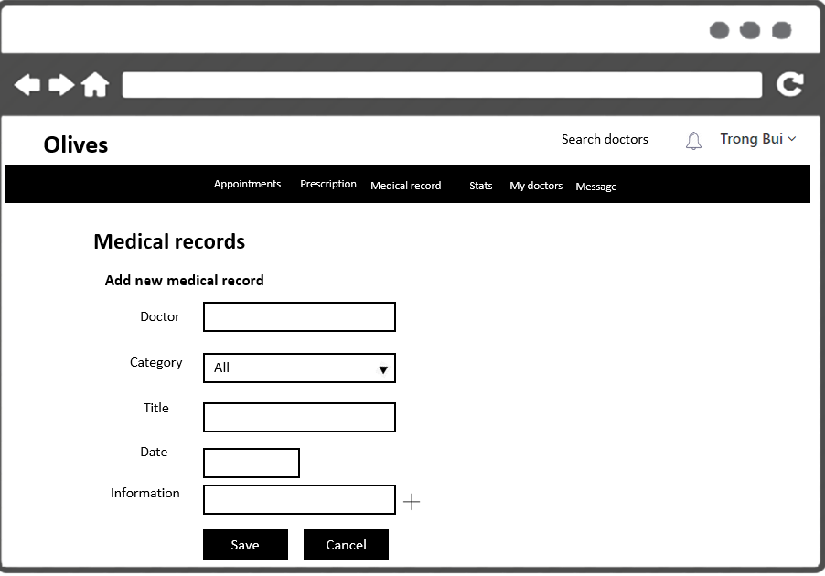

|  |  |  |
| --- | --- | --- |
| Element | Type | Description |
| Doctor | Text input | Text field for entering doctor name |
| Category | Select input | Selection to select medical category |
| Title | Text input | Text field for entering title |
| Date | Text input | Text field for entering date |
| Information | Text input | Text field for entering information |
| Save | Button | Click to save |
| Cancel | Button | Click to cancel action |

## Edit medical record

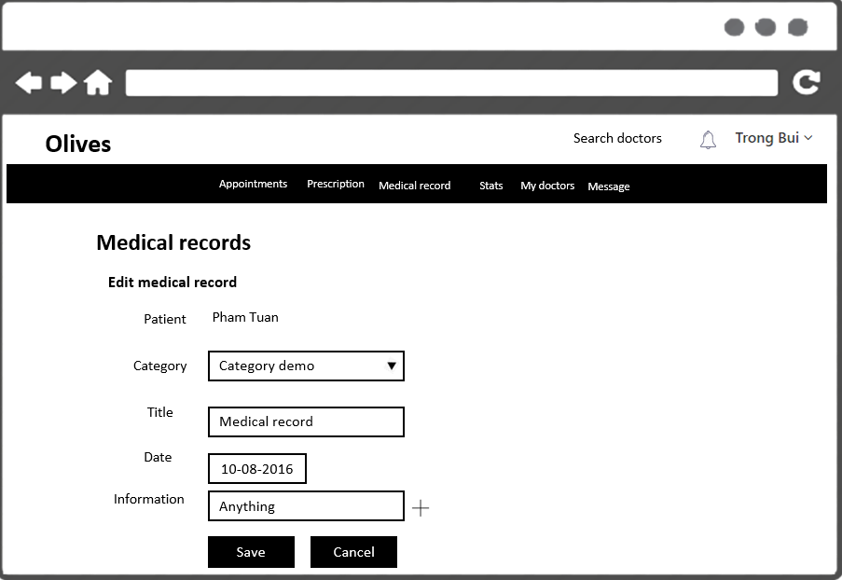

|  |  |  |
| --- | --- | --- |
| Element | Type | Description |
| Doctor | Text input | Text field for entering doctor name |
| Category | Select input | Selection to select medical category |
| Title | Text input | Text field for entering title |
| Date | Text input | Text field for entering date |
| Information | Text input | Text field for entering information |
| Save | Button | Click to save |
| Cancel | Button | Click to cancel action |

## View prescription

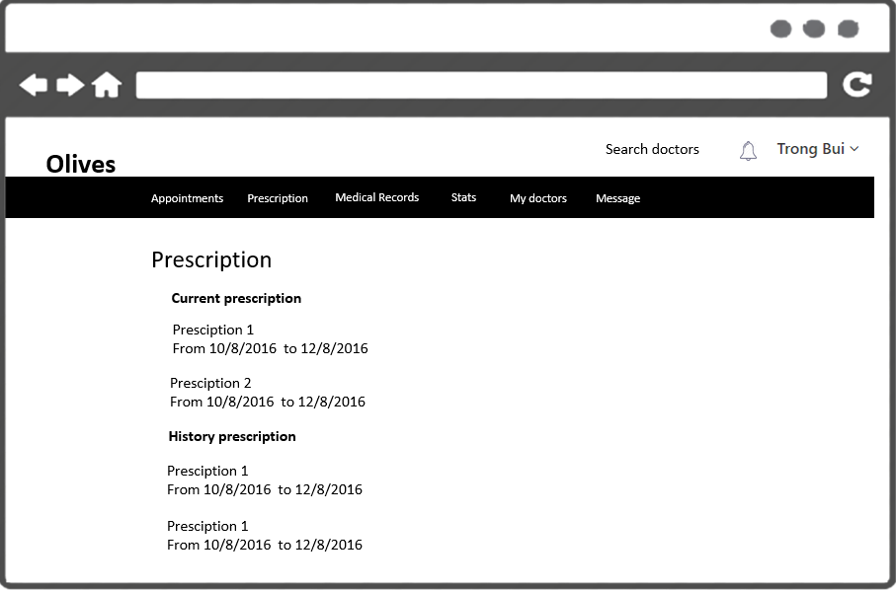

|  |  |  |
| --- | --- | --- |
| Element | Type | Description |
| Prescription list | List element | List of prescription |

## New prescription

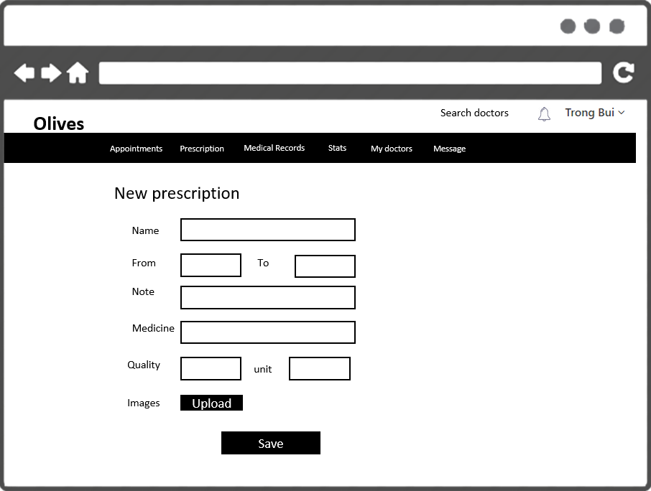

|  |  |  |
| --- | --- | --- |
| Element | Type | Description |
| Name | List element | Name of prescription |
| From | Input Text | Text field for entering duration of prescription |
| To | Input Text | Text field for entering duration of prescription |
| Note | Textarea | Textarea for entering note of prescription |
| Medicine | Input Text | Text field for entering name of medicine |
| Quantity | Input Text | Text field for entering quantity of medicine |
| Unit | Input Text | Text field for entering unit measure |
| Upload | Button | Click to upload prescription images |
| Save | Button | Click to save prescription |

## Edit prescription

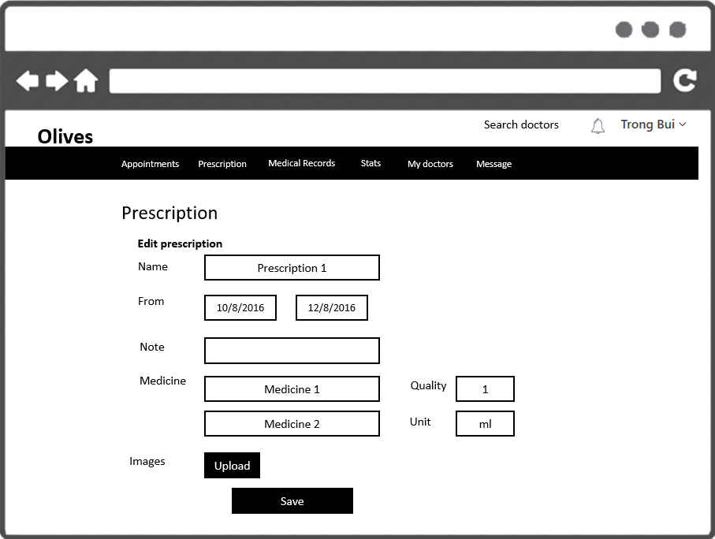

|  |  |  |
| --- | --- | --- |
| Element | Type | Description |
| Name | List element | Name of prescription |
| From | Input Text | Text field for entering duration of prescription |
| Note | Textarea | Textarea for entering note of prescription |
| Medicine | Input Text | Text field for entering name of medicine |
| Quantity | Input Text | Text field for entering quantity of medicine |
| Unit | Input Text | Text field for entering unit measure |
| Upload | Button | Click to upload prescription images |
| Save | Button | Click to save prescription |

## View medical note

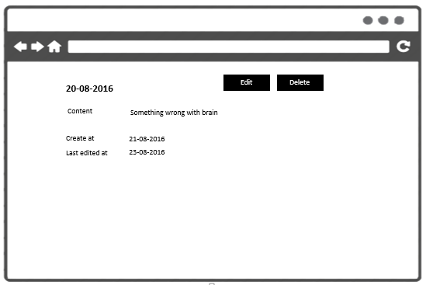

|  |  |  |
| --- | --- | --- |
| Element | Type | Description |
| Date | List element | Text for displaying for displaying date |
| Content | Input Text | Text field for displaying content of medical note |
| Create at | Textarea | Text field for displaying time medical note was created |
| Last edited at | Input Text | Text field for displaying last time medical note was edited |
| Edit | Button | Click to edit medical note |
| Delete | Button | Click to delete medical note |

## Add new medical note

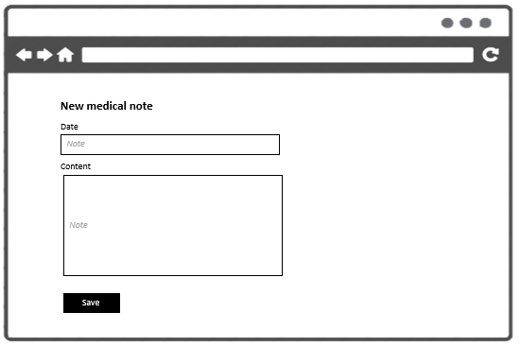

|  |  |  |
| --- | --- | --- |
| Element | Type | Description |
| Date | Text input | Text field for entering date |
| Content | Text input | Text field for entering content |
| Save | Button | Click to save |

## Edit medical note

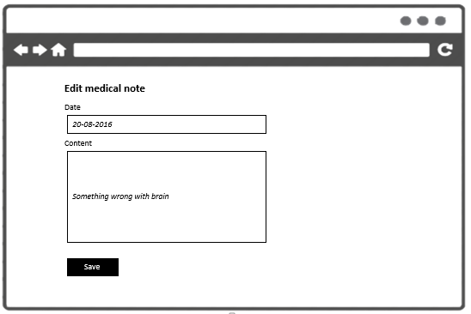

|  |  |  |
| --- | --- | --- |
| Element | Type | Description |
| Date | Text input | Text field for entering date |
| Content | Text input | Text field for entering content |
| Save | Button | Click to save |

## View medical experiment

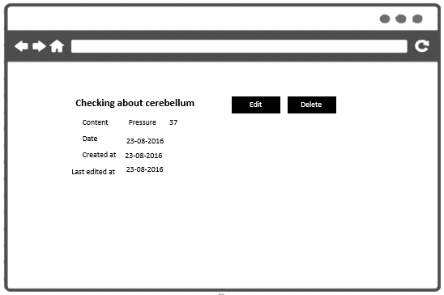

|  |  |  |
| --- | --- | --- |
| Element | Type | Description |
| Title | Text | Text for displaying title of experiment |
| Content | Text | Text for displaying content of experiment |
| Date | Text | Text for displaying date of experiment |
| Created | Text | Text for displaying time experiment was created |
| Last edited at | Text | Text for displaying last time experiment was edited |
| Edit | Button | Click to edit experiment |
| Delete | Button | Delete experiment |

## Add medical experiment

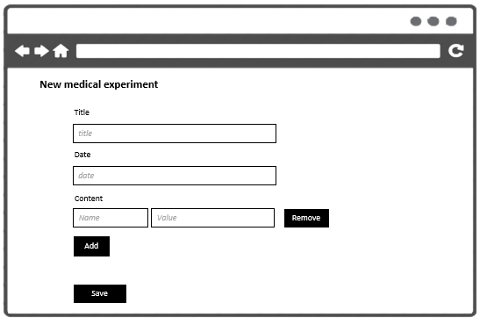

|  |  |  |
| --- | --- | --- |
| Element | Type | Description |
| Title | Text input | Text for displaying title of experiment |
| Content | Text input | Text for displaying content of experiment |
| Date | Text input | Text for displaying date of experiment |
| Remove | Button | Remove content item |
| Add | Button | Add new content item for input value |
| Save | Button | Save medical experiment |

## Edit medical experiment

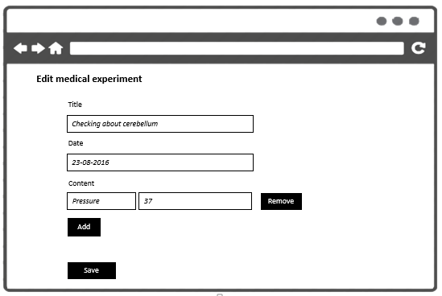

|  |  |  |
| --- | --- | --- |
| Element | Type | Description |
| Title | Text input | Text for displaying title of experiment |
| Content | Text input | Text for displaying content of experiment |
| Date | Text input | Text for displaying date of experiment |
| Remove | Button | Remove content item |
| Add | Button | Add new content item for input value |
| Save | Button | Save medical experiment |

## View medical image

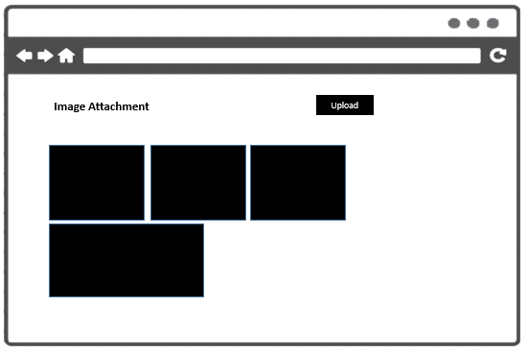

|  |  |  |
| --- | --- | --- |
| Element | Type | Description |
| Images | List of images | Display all images of medical record |
| Upload | Button | Click to upload image |

## Upload medical image

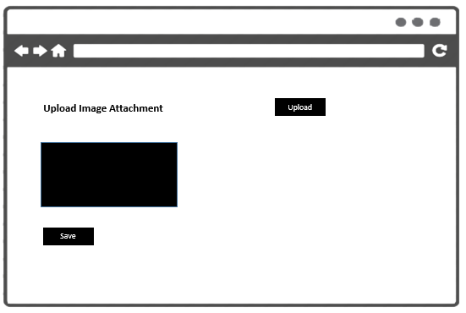

|  |  |  |
| --- | --- | --- |
| Element | Type | Description |
| Images | List of images | Display all uploaded images |
| Upload | Button | Click to upload new image |
| Save | Button | Click to save uploaded images |

## View medical experiment index

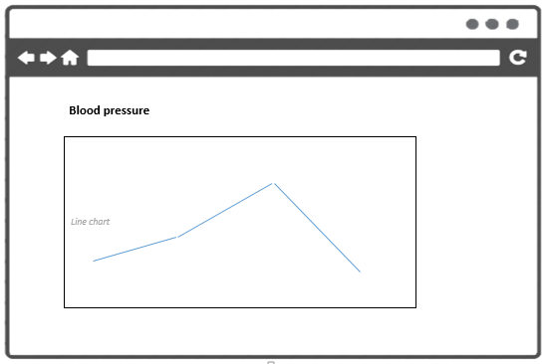

|  |  |  |
| --- | --- | --- |
| Element | Type | Description |
| Chart | Chart view | Display record in line chart |
| Title | Text | Name of chart |

# PATIENT

## Forgot password

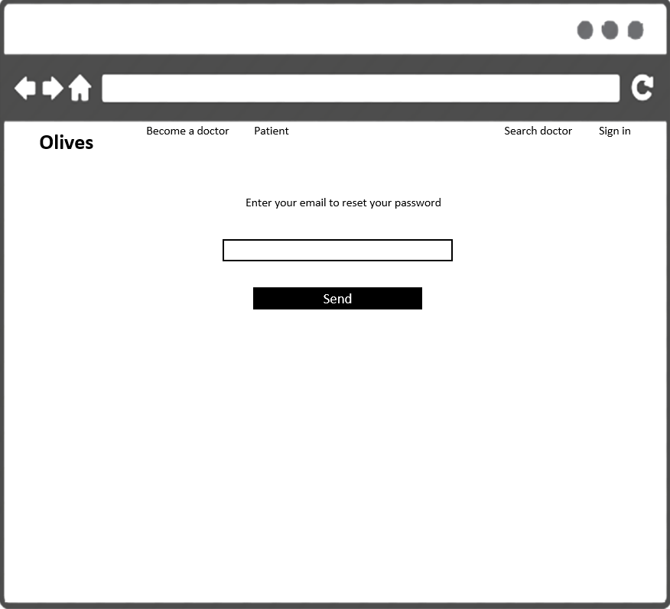

|  |  |  |
| --- | --- | --- |
| Element | Type | Description |
| Email | Input Text | Text filed for entering email of user |
| Send | Button | Click to send request new password |

## View profile



|  |  |  |
| --- | --- | --- |
| Element | Type | Description |
| Name | Text field | Text field for displaying name |
| Email | Hyperlink | Link to patient email |
| Photo | Image | Image displaying patient photo |
| Weight | Text field | Text field for displaying weight |
| Height | Text field | Text field for displaying height |
| Address | Text field | Text field for displaying address |
| Date of birth | Text field | Text field for displaying date of birth |

## User options



|  |  |  |
| --- | --- | --- |
| Element | Type | Description |
| Profile | Hyperlink | Go to user’s profile |
| Settings | Hyperlink | Go to user settings |
| Sign out | Hyperlink | Go to sign user out |

## Setting - password

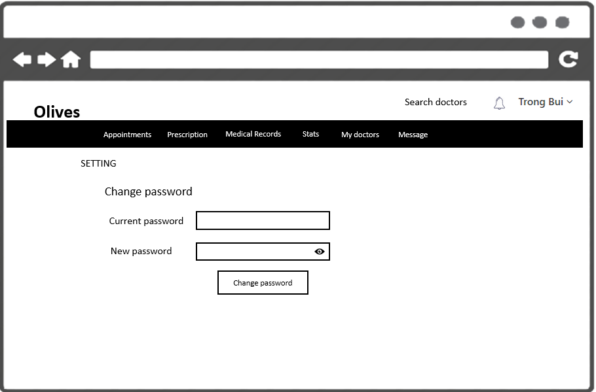

|  |  |  |
| --- | --- | --- |
| Element | Type | Description |
| Current password | Input Text | Text filed for entering old password of user |
| New password | Input Text | Text filed for entering new password of user |
| Change password | Button | Click to save new password |

## Setting - photo



|  |  |  |
| --- | --- | --- |
| Element | Type | Description |
| Upload | Button | Click to upload photo |
| Save | Button | Click to submit change |

## Settings-profile

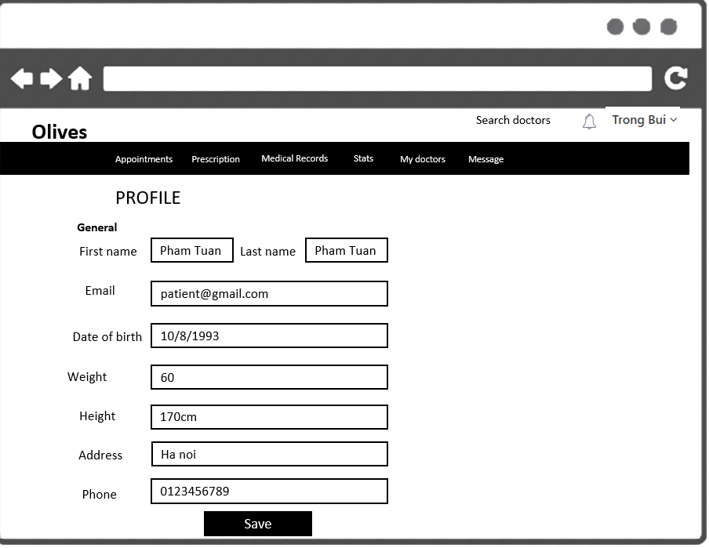

|  |  |  |
| --- | --- | --- |
| Element | Type | Description |
| First name | Text input | Text filed for entering first name |
| Last name | Text input | Text filed for entering last name |
| Email | Text input | Text field for entering email |
| Date of birth | Text input | Text field for entering date of birth |
| Weight | Text input | Text filed for entering weight |
| Height | Text input | Text filed for entering height |
| Address | Text input | Text filed for entering address |
| Phone | Text input | Text filed for entering phone |
| Save | Button | Click to save |

## Search doctor

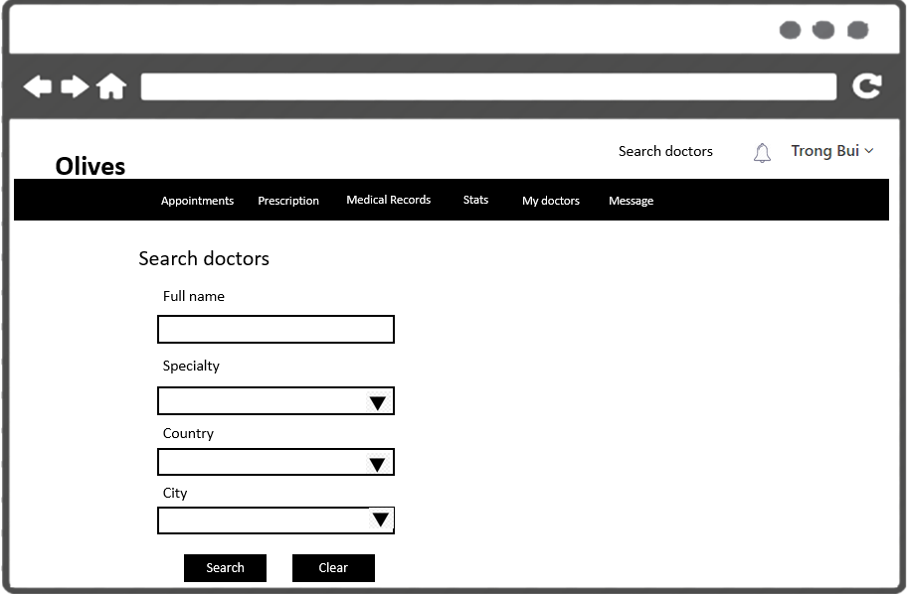

|  |  |  |
| --- | --- | --- |
| Element | Type | Description |
| Full name | Hyperlink | Text field for entering full name |
| Specialty | Hyperlink | Selection field for selecting specialty |
| Country | Hyperlink | Selection field for selecting country |
| City | Hyperlink | Selection field for selecting city |
| Search | Button | Click to search |
| Clear | Button | Click to clear all input |

## Notification

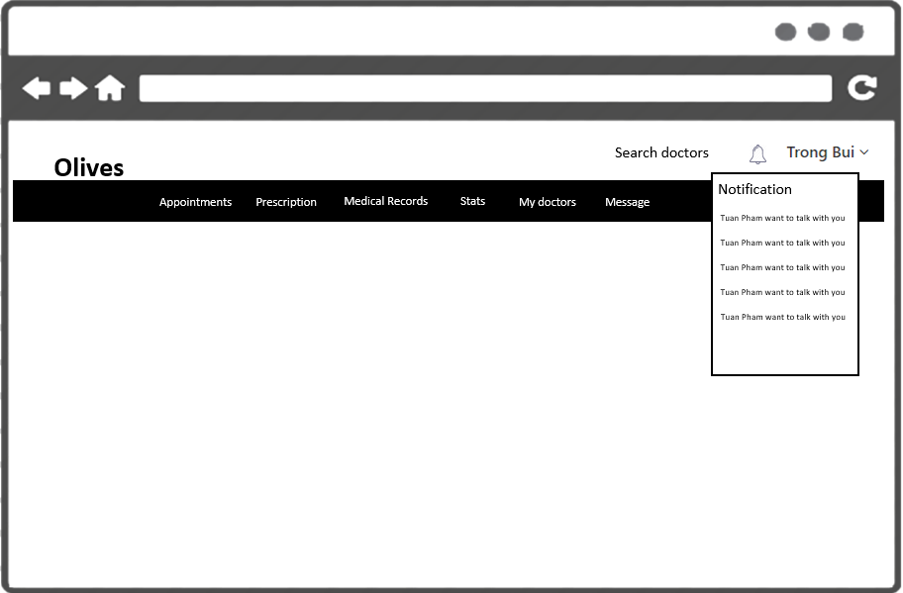

|  |  |  |
| --- | --- | --- |
| Element | Type | Description |
| Bell icon | Button | Click to show notification |
| List item | List element | Show all notification |

## Message

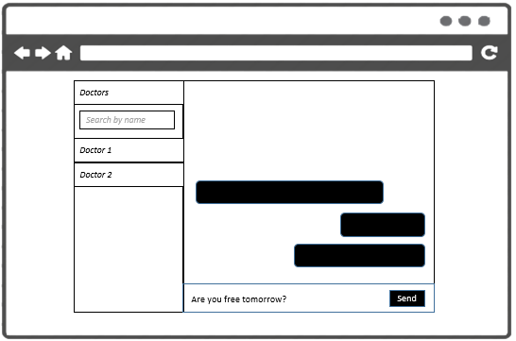

|  |  |  |
| --- | --- | --- |
| Element | Type | Description |
| Doctor list | List of text fields | Displaying list of doctors |
| Search | Text input | Text input for entering name of doctors |
| Message list | List of text fields | Displaying list of messages |
| Content | Textarea | Textarea for entering message content |
| Send | Button | Click to send message |

## View profile

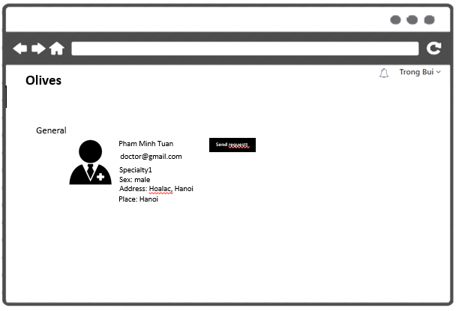

|  |  |  |
| --- | --- | --- |
| Element | Type | Description |
| Name | Text field | Text filed for entering name of user |
| Email | Hyperlink | Link to email |
| Specialty | Text field | Text field for displaying specialty |
| Sex | Text field | Text field for displaying sex |
| Address | Text field | Text field for displaying address |
| Place | Text field | Text field for display place |
| Photo | Image | Image for displaying photo |
| Send request | Button | Click to send relationship request |

## Add appointment

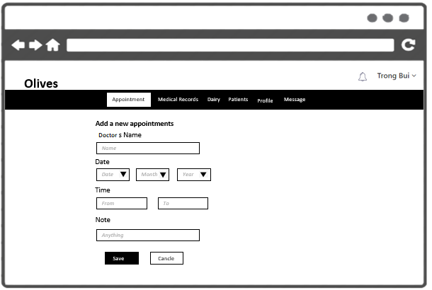

|  |  |  |
| --- | --- | --- |
| Element | Type | Description |
| Doctor’s name | Input text | Text field for entering name |
| Date | Text input | Text filed for entering date |
| Time | Text input | Text field for entering time |
| Note | Textarea | Textarea for entering note |
| Save | Button | Click to save appointment |
| Cancel | Button | Click to cancel action |

## Edit appointment



|  |  |  |
| --- | --- | --- |
| Element | Type | Description |
| Doctor’s name | Input text | Text field for entering name |
| Date | Text input | Text filed for entering date |
| Time | Text input | Text field for entering time |
| Note | Textarea | Textarea for entering note |
| Save | Button | Click to save appointment |
| Cancel | Button | Click to cancel action |

## Accept appointment



|  |  |  |
| --- | --- | --- |
| Element | Type | Description |
| Note | Input text | Text field for entering note |
| Proceed | Button | Click to accept appointment |
| Cancel | Button | Click to cancel action |

## Cancel appointment



|  |  |  |
| --- | --- | --- |
| Element | Type | Description |
| Note | Input text | Text field for entering note |
| Proceed | Button | Click to cancel appointment |
| Cancel | Button | Click to cancel action |

## View activated appointments

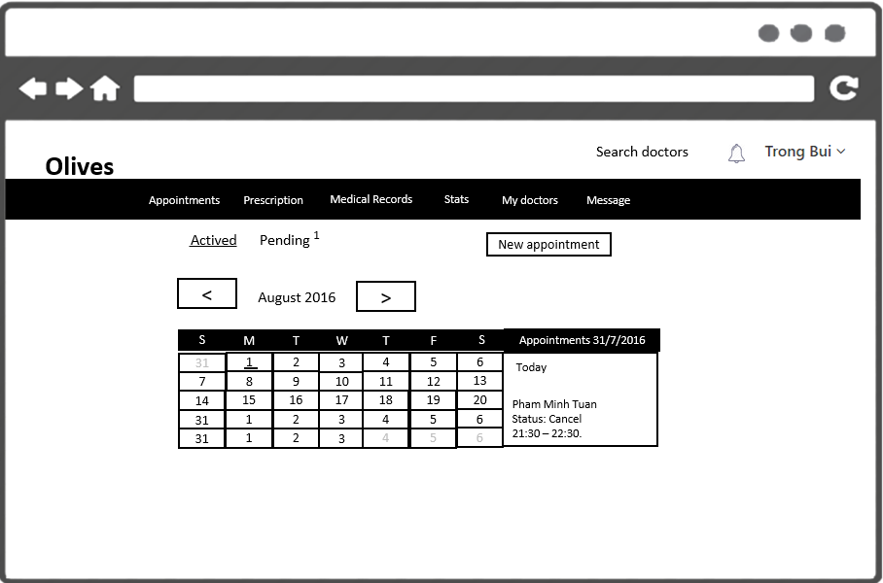

|  |  |  |
| --- | --- | --- |
| Element | Type | Description |
| Left arrow | Button | Click to show notification |
| Right arrow | Button | Show all notification |
| August 2016 | Button | Show month and year |
| Calendar | Calendar | Show days of month |
| Appointments | List element | Show all activated appointment |
| New appointment | Button | Click to go to add new appointment |

## View pending appointments



|  |  |  |
| --- | --- | --- |
| Element | Type | Description |
| From me | Checkbox | Radio button for get appointment created by doctor |
| From others | Checkbox | Radio button for get appointment created by patients |
| Name of partner | Button | Text field for displaying name |
| Note | Calendar | Text field for displaying note |
| Duration | List element | Text field for displaying appointment’s duration |
| Accept | Button | Click to accept appointment |
| Cancel | Button | Click to cancel appointment |

## Search appointment



|  |  |  |
| --- | --- | --- |
| Element | Type | Description |
| From | Text input | Text input for entering duration |
| To | Text input | Text input for entering duration |
| Search | Button | Click to search |
| Partner’s name | Text | Text field for displaying partner’s name |
| Note | Text | Text field for displaying note |
| Time | Text | Text field for display time of appointment |

## View medical records



|  |  |  |
| --- | --- | --- |
| Element | Type | Description |
| Category selection | Selection | Select medical category |
| Add new | Button | Click to add new medical record |
| List item | List element | List of medical record |

## Add new medical record



|  |  |  |
| --- | --- | --- |
| Element | Type | Description |
| Doctor | Text input | Text field for entering doctor name |
| Category | Select input | Selection to select medical category |
| Title | Text input | Text field for entering title |
| Date | Text input | Text field for entering date |
| Information | Text input | Text field for entering information |
| Save | Button | Click to save |
| Cancel | Button | Click to cancel action |

## Edit medical record



|  |  |  |
| --- | --- | --- |
| Element | Type | Description |
| Doctor | Text input | Text field for entering doctor name |
| Category | Select input | Selection to select medical category |
| Title | Text input | Text field for entering title |
| Date | Text input | Text field for entering date |
| Information | Text input | Text field for entering information |
| Save | Button | Click to save |
| Cancel | Button | Click to cancel action |

## View prescription



|  |  |  |
| --- | --- | --- |
| Element | Type | Description |
| Prescription list | List element | List of prescription |

## Edit prescription



|  |  |  |
| --- | --- | --- |
| Element | Type | Description |
| Name | List element | Name of prescription |
| From | Input Text | Text field for entering duration of prescription |
| Note | Textarea | Textarea for entering note of prescription |
| Medicine | Input Text | Text field for entering name of medicine |
| Quantity | Input Text | Text field for entering quantity of medicine |
| Unit | Input Text | Text field for entering unit measure |
| Upload | Button | Click to upload prescription images |
| Save | Button | Click to save prescription |

Delete prescription

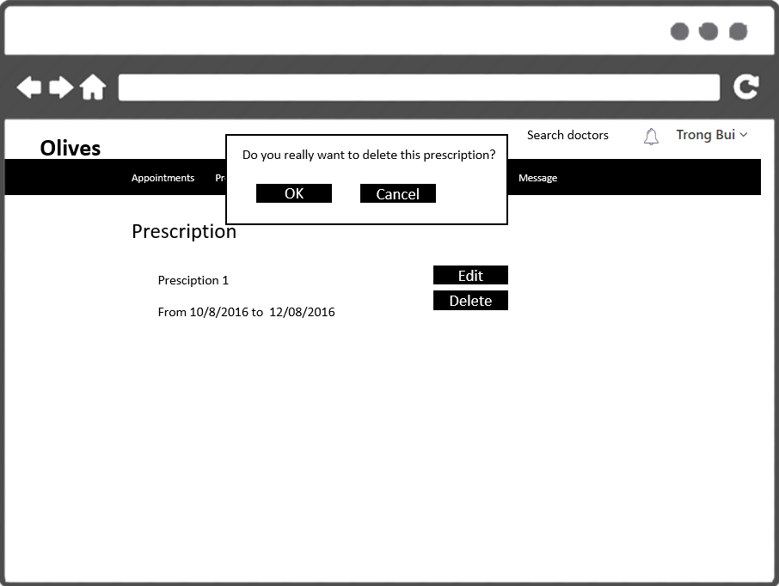

|  |  |  |
| --- | --- | --- |
| Element | Type | Description |
| Delete | Button | Click to delete prescription |
| Ok | Button | Click to proceed action |
| Cancel | Button | Click to cancel delete action |

## New prescription



|  |  |  |
| --- | --- | --- |
| Element | Type | Description |
| Name | List element | Name of prescription |
| From | Input Text | Text field for entering duration of prescription |
| To | Input Text | Text field for entering duration of prescription |
| Note | Textarea | Textarea for entering note of prescription |
| Medicine | Input Text | Text field for entering name of medicine |
| Quantity | Input Text | Text field for entering quantity of medicine |
| Unit | Input Text | Text field for entering unit measure |
| Upload | Button | Click to upload prescription images |
| Save | Button | Click to save prescription |

## View medical note



|  |  |  |
| --- | --- | --- |
| Element | Type | Description |
| Date | List element | Text for displaying for displaying date |
| Content | Input Text | Text field for displaying content of medical note |
| Create at | Textarea | Text field for displaying time medical note was created |
| Last edited at | Input Text | Text field for displaying last time medical note was edited |
| Edit | Button | Click to edit medical note |
| Delete | Button | Click to delete medical note |

## Add new medical note



|  |  |  |
| --- | --- | --- |
| Element | Type | Description |
| Date | Text input | Text field for entering date |
| Content | Text input | Text field for entering content |
| Save | Button | Click to save |

## Edit medical note



|  |  |  |
| --- | --- | --- |
| Element | Type | Description |
| Date | Text input | Text field for entering date |
| Content | Text input | Text field for entering content |
| Save | Button | Click to save |

## View medical experiment



|  |  |  |
| --- | --- | --- |
| Element | Type | Description |
| Title | Text | Text for displaying title of experiment |
| Content | Text | Text for displaying content of experiment |
| Date | Text | Text for displaying date of experiment |
| Created | Text | Text for displaying time experiment was created |
| Last edited at | Text | Text for displaying last time experiment was edited |
| Edit | Button | Click to edit experiment |
| Delete | Button | Delete experiment |

## Add medical experiment



|  |  |  |
| --- | --- | --- |
| Element | Type | Description |
| Title | Text input | Text for displaying title of experiment |
| Content | Text input | Text for displaying content of experiment |
| Date | Text input | Text for displaying date of experiment |
| Remove | Button | Remove content item |
| Add | Button | Add new content item for input value |
| Save | Button | Save medical experiment |

## Edit medical experiment



|  |  |  |
| --- | --- | --- |
| Element | Type | Description |
| Title | Text input | Text for displaying title of experiment |
| Content | Text input | Text for displaying content of experiment |
| Date | Text input | Text for displaying date of experiment |
| Remove | Button | Remove content item |
| Add | Button | Add new content item for input value |
| Save | Button | Save medical experiment |

## View medical image



|  |  |  |
| --- | --- | --- |
| Element | Type | Description |
| Images | List of images | Display all images of medical record |
| Upload | Button | Click to upload image |

## Upload medical image



|  |  |  |
| --- | --- | --- |
| Element | Type | Description |
| Images | List of images | Display all uploaded images |
| Upload | Button | Click to upload new image |
| Save | Button | Click to save uploaded images |

## View medical experiment index



|  |  |  |
| --- | --- | --- |
| Element | Type | Description |
| Chart | Chart view | Display record in line chart |
| Title | Text | Name of chart |

## View profile

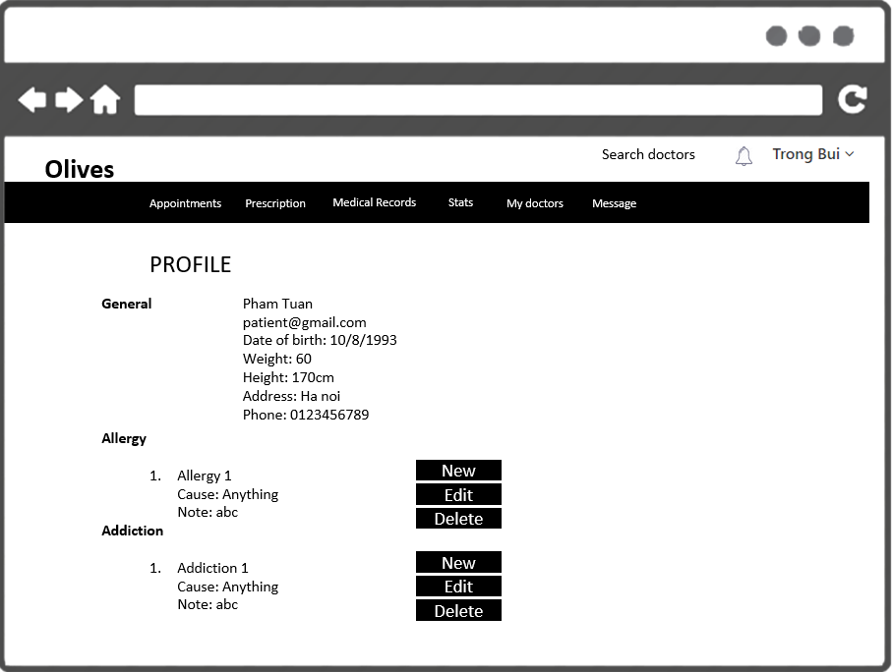

|  |  |  |
| --- | --- | --- |
| Element | Type | Description |
| Name | Text field | Text field for displaying name |
| Email | Hyperlink | Hyperlink for email link |
| Date of birth | Text field | Text field for displaying date of birth |
| Weight | Text field | Text field for displaying weight |
| Height | Text field | Text field for displaying height |
| Address | Text field | Text field for displaying address |
| Phone | Text field | Text field for displaying phone |
| Allergy1 | Text field | Text field for displaying allergy’s name |
| Cause | Text field | Text field for displaying allergy’s cause |
| Note | Text field | Text field for displaying allergy’s note |
| Allergy - New | Button | Click to add new allergy |
| Allergy – Edit | Button | Click to edit allergy |
| Allergy - Delete | Button | Click to delete allergy |
| Addiction - New | Button | Click to add new addiction |
| Addiction – Edit | Button | Click to edit addiction |
| Addiction - Delete | Button | Click to delete addiction |

## Edit allergy

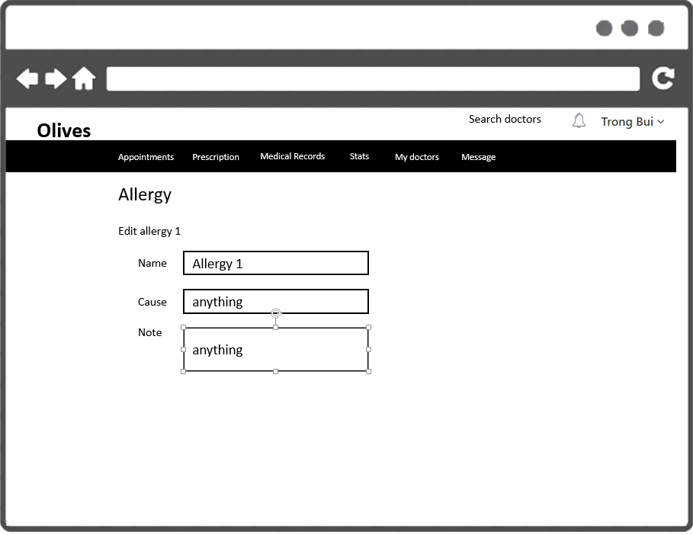

|  |  |  |
| --- | --- | --- |
| Element | Type | Description |
| Name | Input Text | Text field for entering allergy’s name |
| Cause | Input Text | Text field for entering cause |
| Note | Input Text | Text field for entering note |
| Save | Button | Click to save |

## Delete allergy

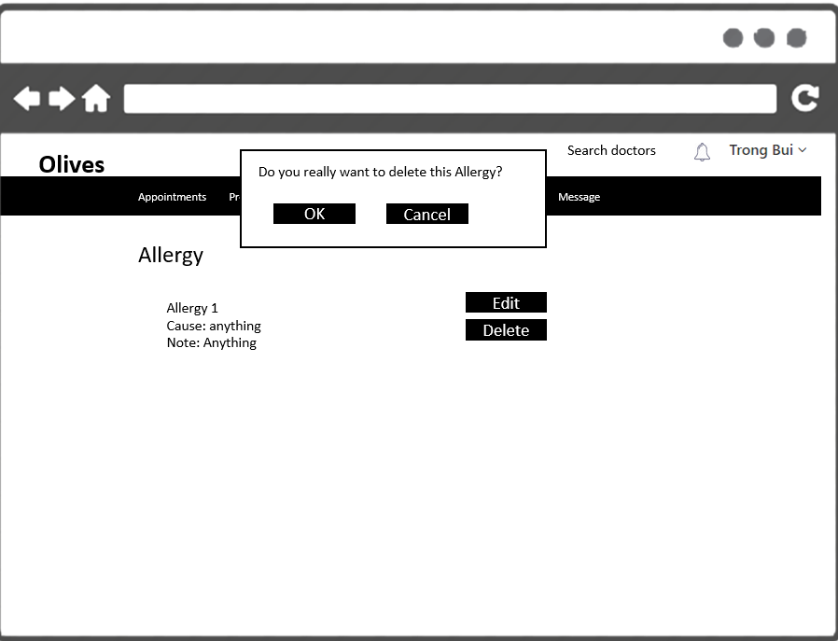

|  |  |  |
| --- | --- | --- |
| Element | Type | Description |
| Ok | Button | Click to proceed delete action |
| Cancel | Button | Click to cancel deleting item |
| Delete | Button | Click to delete |

## Add allergy

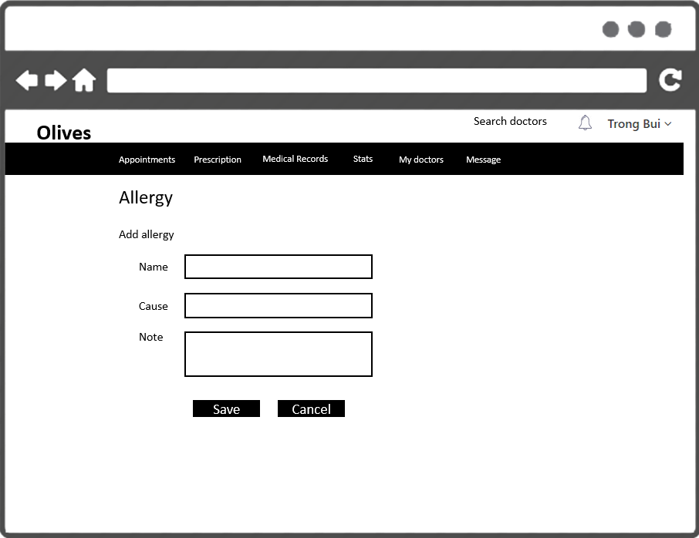

|  |  |  |
| --- | --- | --- |
| Element | Type | Description |
| Name | Input Text | Text field for entering allergy’s name |
| Cause | Input Text | Text field for entering cause |
| Note | Input Text | Text field for entering note |
| Save | Button | Click to save |
| Cancel | Button | Click to cancel |

## Edit addiction

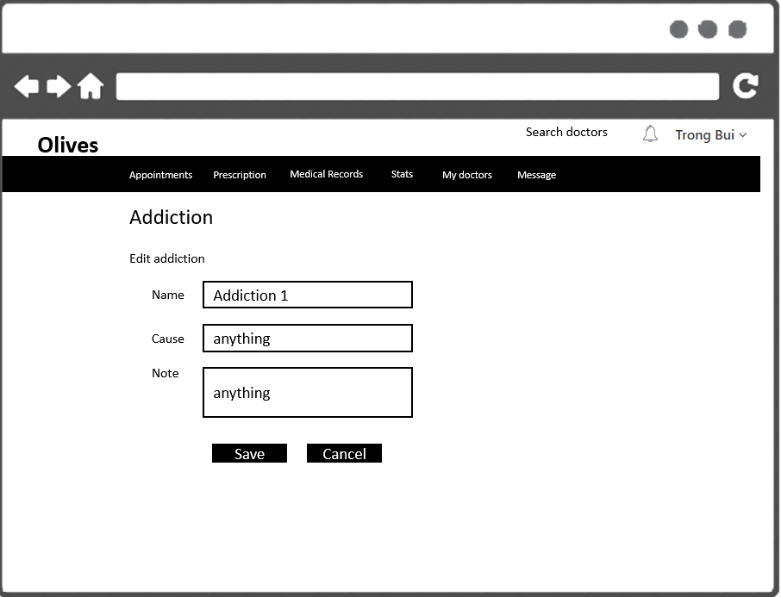

|  |  |  |
| --- | --- | --- |
| Element | Type | Description |
| Name | Input Text | Text field for entering addiction name |
| Cause | Input Text | Text field for entering cause |
| Note | Input Text | Text field for entering note |
| Save | Button | Click to save |
| Cancel | Button | Click to cancel |

## Delete addiction

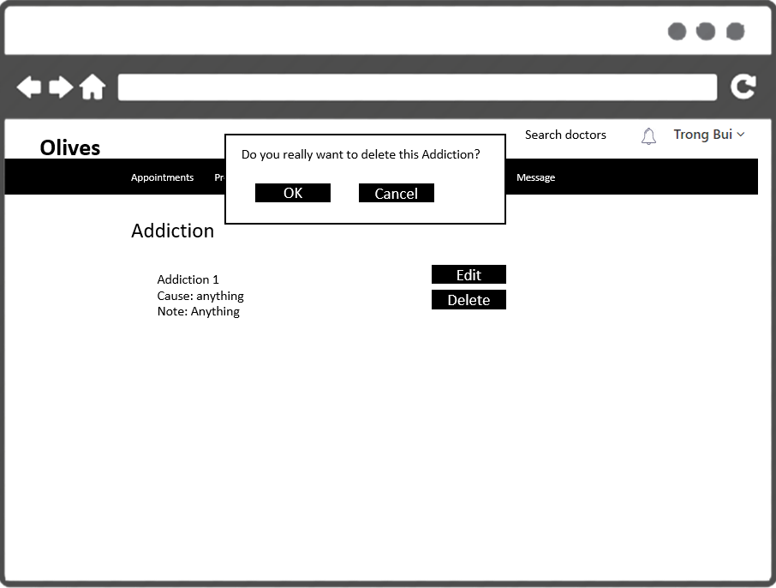

|  |  |  |
| --- | --- | --- |
| Element | Type | Description |
| Ok | Button | Click to proceed delete action |
| Cancel | Button | Click to cancel deleting item |
| Delete | Button | Click to delete |

## Add addiction

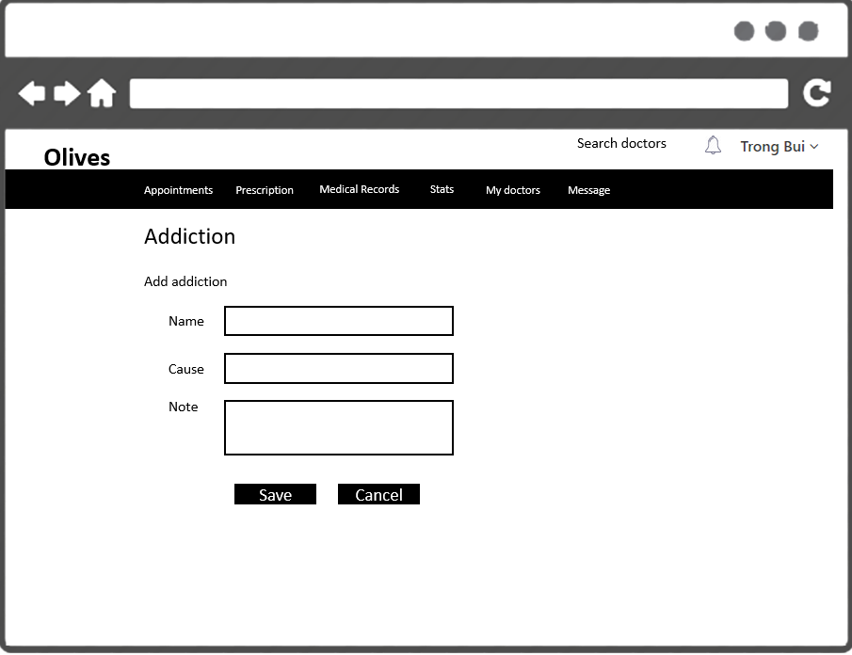

|  |  |  |
| --- | --- | --- |
| Element | Type | Description |
| Name | Input Text | Text field for entering addiction name |
| Cause | Input Text | Text field for entering cause |
| Note | Input Text | Text field for entering note |
| Save | Button | Click to save |
| Cancel | Button | Click to cancel |

## Show heartbeat record

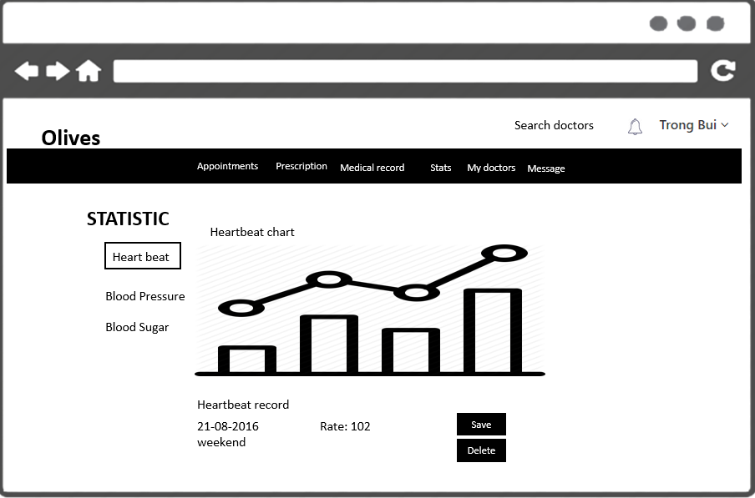

|  |  |  |
| --- | --- | --- |
| Element | Type | Description |
| Chart | Chart element | Chart for displaying statistic |
| Date | Text | Text element for display date time |
| Rate | Text | Text element for display rate |
| Delete | Button | Click to delete |

## Add heartbeat

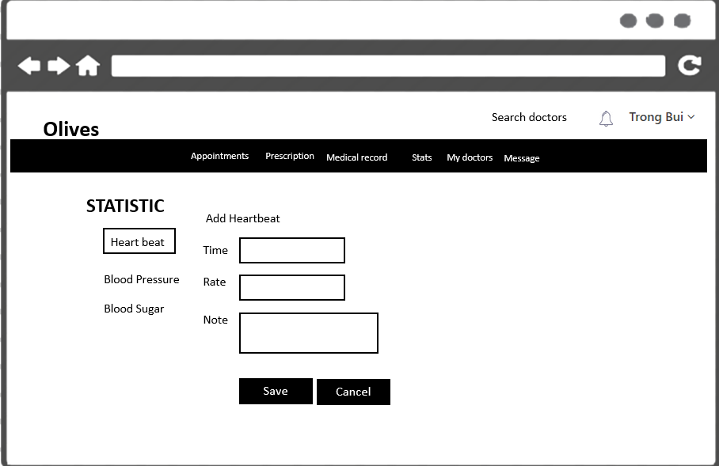

|  |  |  |
| --- | --- | --- |
| Element | Type | Description |
| Time | Text | Text field for entering time |
| Rate | Text | Text field for entering rate value |
| Note | Text | Text field for entering note |
| Save | Button | Click to save heartbeat record |
| Cancel | Button | Click to cancel action |

## Edit heartbeat

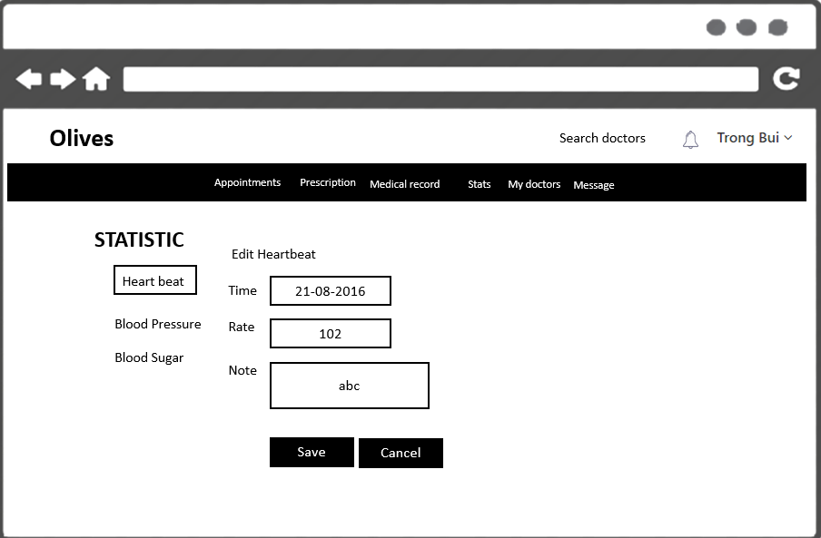

|  |  |  |
| --- | --- | --- |
| Element | Type | Description |
| Time | Text | Text field for entering time |
| Rate | Text | Text field for entering rate value |
| Note | Text | Text field for entering note |
| Save | Button | Click to save heartbeat record |
| Cancel | Button | Click to cancel action |

## Delete heartbeat

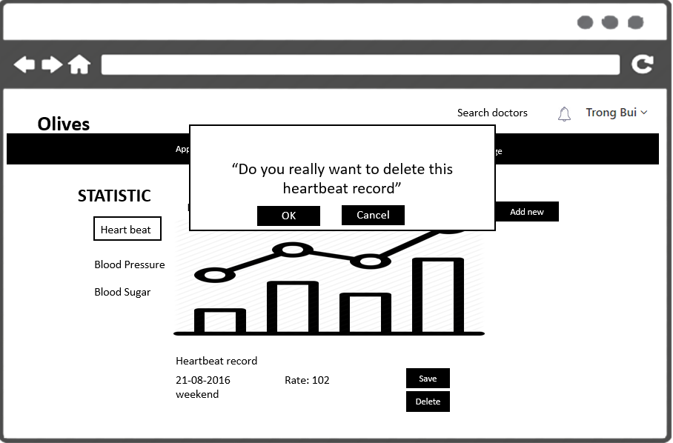

|  |  |  |
| --- | --- | --- |
| Element | Type | Description |
| Ok | Button | Click to proceed delete action |
| Cancel | Button | Click to cancel deleting item |
| Delete | Button | Click to delete |

## View blood pressure records

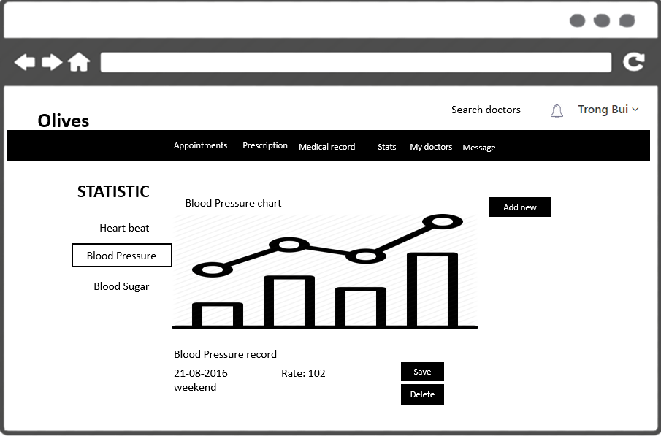

|  |  |  |
| --- | --- | --- |
| Element | Type | Description |
| Chart | Chart element | Chart for displaying statistic |
| Date | Text | Text element for display date time |
| Rate | Text | Text element for display rate |
| Delete | Button | Click to delete |

## Add blood pressure

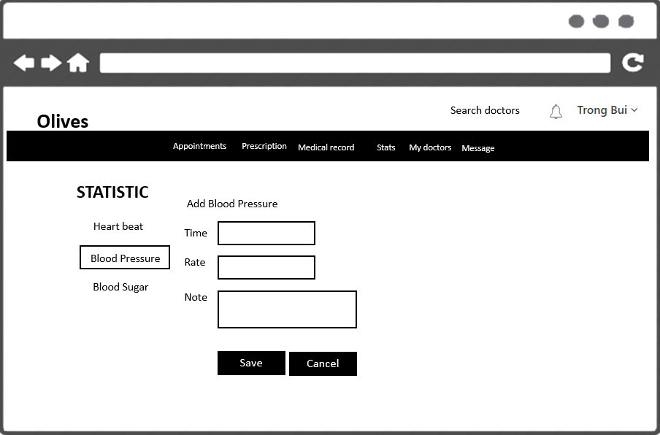

|  |  |  |
| --- | --- | --- |
| Element | Type | Description |
| Time | Text | Text field for entering time |
| Rate | Text | Text field for entering rate value |
| Note | Text | Text field for entering note |
| Save | Button | Click to save blood pressure record |
| Cancel | Button | Click to cancel action |

## Edit blood pressure

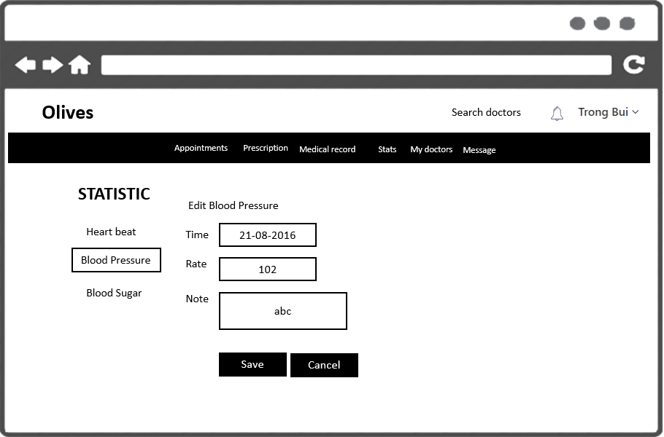

|  |  |  |
| --- | --- | --- |
| Element | Type | Description |
| Time | Text | Text field for entering time |
| Rate | Text | Text field for entering rate value |
| Note | Text | Text field for entering note |
| Save | Button | Click to save heartbeat record |
| Cancel | Button | Click to cancel action |

## Delete blood pressure

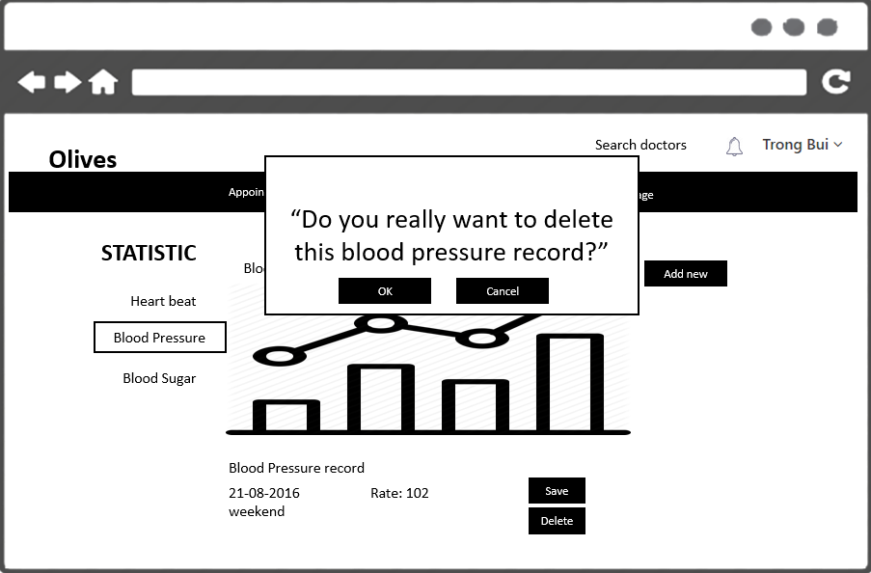

|  |  |  |
| --- | --- | --- |
| Element | Type | Description |
| Ok | Button | Click to proceed delete action |
| Cancel | Button | Click to cancel deleting item |
| Delete | Button | Click to delete |

## View blood sugar records

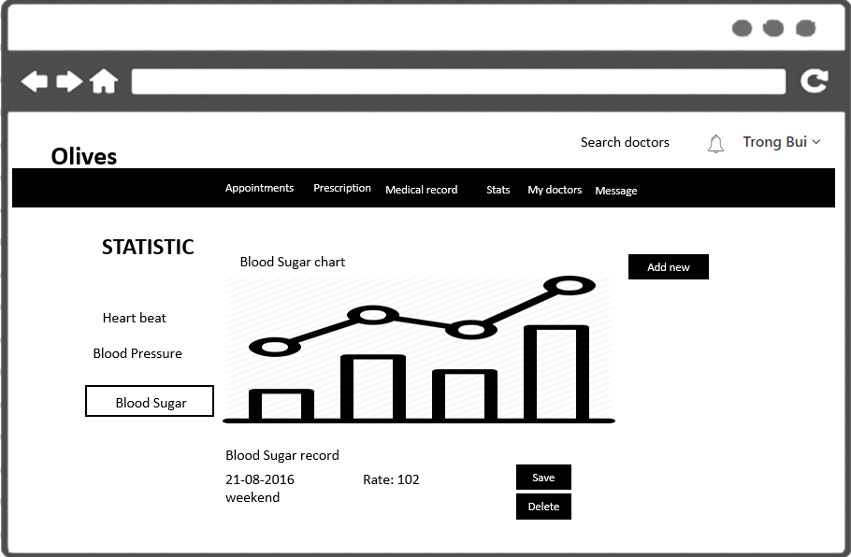

|  |  |  |
| --- | --- | --- |
| Element | Type | Description |
| Chart | Chart element | Chart for displaying statistic |
| Date | Text | Text element for display date time |
| Rate | Text | Text element for display rate |
| Delete | Button | Click to delete |

## Add blood sugar



|  |  |  |
| --- | --- | --- |
| Element | Type | Description |
| Time | Text | Text field for entering time |
| Rate | Text | Text field for entering rate value |
| Note | Text | Text field for entering note |
| Save | Button | Click to save blood pressure record |
| Cancel | Button | Click to cancel action |

## Edit blood sugar

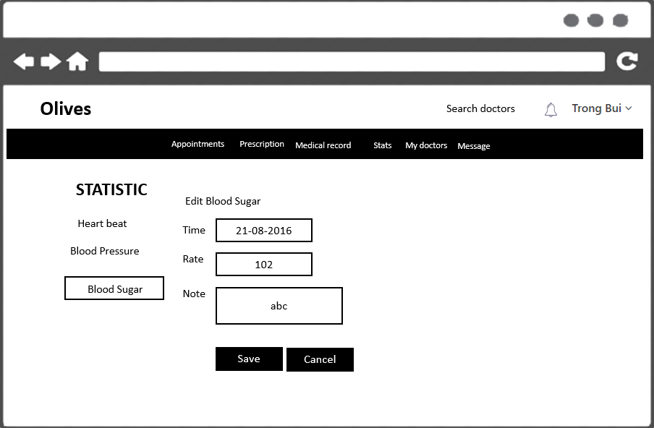

|  |  |  |
| --- | --- | --- |
| Element | Type | Description |
| Time | Text | Text field for entering time |
| Rate | Text | Text field for entering rate value |
| Note | Text | Text field for entering note |
| Save | Button | Click to save heartbeat record |
| Cancel | Button | Click to cancel action |

## Delete blood sugar

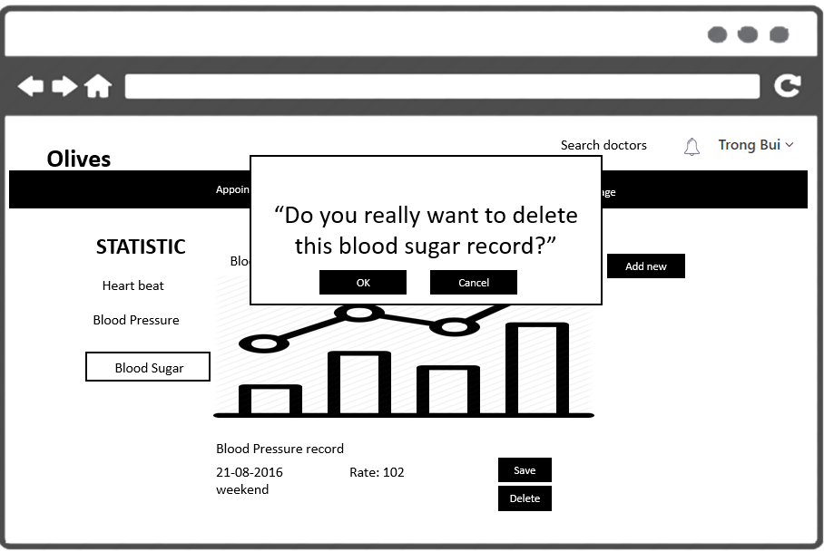

|  |  |  |
| --- | --- | --- |
| Element | Type | Description |
| Ok | Button | Click to proceed delete action |
| Cancel | Button | Click to cancel deleting item |
| Delete | Button | Click to delete |